Coupled Dynamic Modeling and Hysteresis-Aware Tension Optimization for Cable-Driven Parallel Robots
Mfeuter Joseph Tachia, Alexander Maloletov
Faculty of Robotics and Computer Visions, Innopolis University, Russia
m.tachia@innopolis.univerity, a.maloletov@innopolis.ru
Abstract— Cable-driven parallel robots offer exceptional workspace and payload capabilities but face significant control challenges from cable elasticity, hysteresis, and friction nonlinearities. This paper presents a unified dynamic modeling and control framework that specifically takes these nonlinear effects into account. The suggested method combines a Bouc–Wen hysteresis model which captures the rate-independent memory behavior of elastic cables under cyclic loading and unloading with a LuGre friction model to accurately represent actuator and winch friction phenomena such as pre-sliding displacement and the Stribeck effect. A new hysteresis-aware quadratic programming (QP)-based tension optimization method is created based on this coupled nonlinear model. In contrast to traditional tension distribution techniques, the suggested optimizer directly integrates friction and hysteresis constraints into the optimization process allowing for real-time feasibility and physically consistent tension allocation. Comprehensive simulations on a spatial 6-DoF CDPR executing dynamic trajectories verify the efficacy of the suggested framework. The outcomes show significant performance gains over baseline methods that ignore friction and hysteresis. In particular, the suggested approach reduces vibration amplitude by 72.7%, cable tension variation by 61.3%, and root-mean-square (RMS) tracking error by 73.0%. Crucially these improvements are achieved with a 95% control loop success rate at a 150 Hz update frequency all while preserving real-time operation. These findings demonstrate the frameworks potential for precise uses in logistics industrial automation and rehabilitation.
Index Terms— Bouc-Wen model, hysteresis modeling, LuGre friction, tension optimization, real-time control.

INTRODUCTION
Cable-driven parallel robots (CDPRs) have gained significant attention for large-workspace applications due to their reconfigurability, scalability, and high payload-to-weight ratios [1], [2], [3]. CDPRs enable applications in warehouse logistics, rehabilitation, construction and automation etc. by substituting flexible cables for rigid links. However, cable elasticity, viscoelastic hysteresis, and actuator friction continue to make high-precision control difficult [4], [5], [6], [7]. Most existing works on CDPR controllers are based on simplified models that assumes rigid platforms, elastic cables and idea actuators [8], [9], [10]. These models are computationally effective but they are unable to represent the nonlinear phenomena that predominate in precision applications. When subjected to cyclic loading, real cables exhibit viscoelastic hysteresis, a history-dependent behavior that causes phase lag and energy dissipation [10], [11], [12]. In addition, winch actuators exhibit stick-slip oscillations close to zero velocity due to velocity-dependent friction and Stribeck effects [12], [13], [14]. Tracking performance is severely degraded by these coupled nonlinearities.
Recent advances have addressed these research problems namely, Bouc-Wen models for cable hysteresis [6], [15] and LuGre models for actuator friction [13], [16] separately. However, a unified framework that couples these nonlinearities within a real- time control strategy remains lacking. Additionally, traditional tension optimization techniques minimize cable forces without taking hysteresis-induced energy dissipation into account [6], [12], [16] which affects the overall performance during trajectory reversals. This paper presents three main contributions:
1. A unified dynamic models that integrates the Bouc-Wen cable hysteresis, LuGre actuator friction and the platform dynamic, are all integrated into a single dynamic model.
2. A tension optimizer for hysteresis-aware quadratic programming that specifically takes nonlinear cable dynamics into account.
3. Simulation validation which shows a significant improvement in computational efficiency, tension smoothness, vibration suppression and tracking accuracy.
The rest of the paper is structured as follows: The system modeling is presented in Section II. The tension optimization with hysteresis awareness is described in Section III. The simulation setup is described in Section IV. The results and their discussion are presented in Section V. The paper is concluded in Section VI with simulation code made available for further research purposes and reference.

System Modeling

Kinematics and Jacobian
Consider a CDPR system with $m$ number of cables which connects a fixed anchor points $A_{i}∈R^{3}$ on the base frame to the platform attachment points $B_{i}$ on the platform. The mobile platform poses also called end-effector (EE) is defined by its position $p ϵ R^{3}$ and the orientation matrix $R ∈SO(3)$. The vector for cable I is given by:
$$l_{i}=A_{i}-\left(p+Rb_{i}\right) (1)$$
where bi is the attachment point expressed in the body frame. The relationship between the cable velocity, and platform velocity is derived considering the cable length $L_{i}$ and its corresponding unit direction vector $u_{i}$, which are given thus:
$$\left\{\begin{aligned}L_{i}=\left\|l_{i}\right\| \\ u_{i}=\frac{{-l}_{i}}{L_{i}}\end{aligned}\right.$$
$$\left\{ \begin{aligned}{\dot{L}}_{i}=J_{i}^{T}\dot{x} \\ J_{i}={\left[\begin{matrix}{-u}_{i}^{T} & {-\left({Rb}_{i}×u_{i}\right)}^{T}\end{matrix}\right]}^{T} (2)\end{aligned}\right.$$
where $x={\left[p^{T},ϕ^{T}\right]}^{T}$represents the platform pose and $ϕ$ is a minimal orientation representation. The relationship between the Jacobian $J∈R^{m×6}$ which maps the platform velocities to the cable rates, and cable tensions $τ∈R^{m}$ to the platform wrench $ω∈R^{6}$ is given by:
$$ω={-J}^{T}τ (3)$$
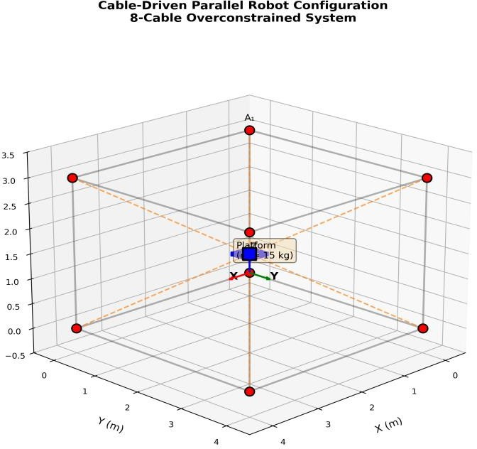
Fig. 1. Schematic of the 8-cable CDPR system showing platform, cable attachment points, and coordinate frames.

Table I: Key Notations and Symbols
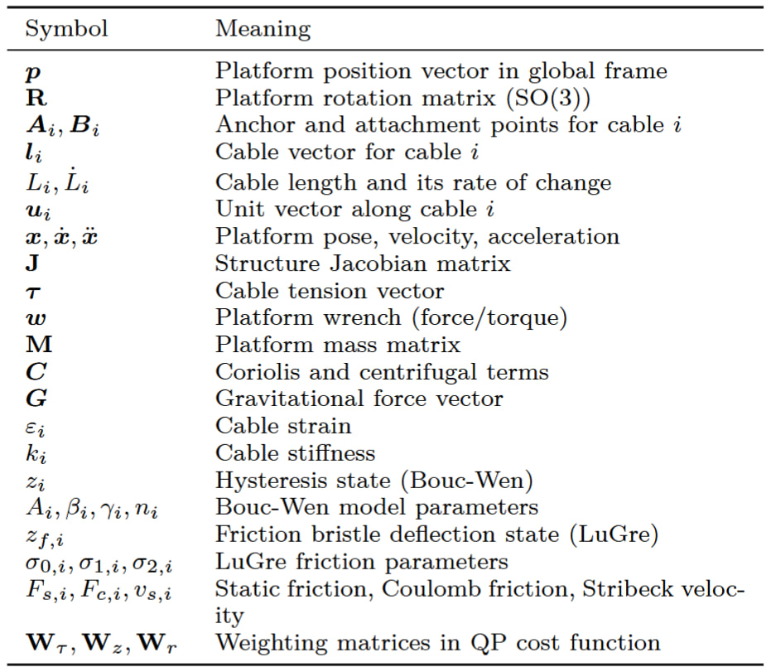

Platform Dynamics
The platform dynamics are derived using the Newton-Euler equations:
$$M\left(x\right)\ddot{x}+C\left(x,\dot{x}\right)\dot{x}+G\left(x\right)= -J^{T}\left(x\right)τ (4)$$
where $M∈R^{6×6}$ is the mass matrix, $C$ is the Coriolis and centrifugal terms, and $G$ represents the gravitational forces. For a platform or EE of mass $m$ and its inertia tensor $I_{b}$ In the body frame, the mass and gravity terms are given by:
$M=\left[\begin{matrix}mI_{3} & 0 \\ 0 & {RI}_{b}R^{T}\end{matrix}\right]$, G = $\left[\begin{matrix}mge_{z} \\ 0\end{matrix}\right] (5)$
where $e_{z}= {\left[0, 0, 1\right]}^{T}$ and $g$ is the acceleration due to gravity.

Bouc-Wen Cable Hysteresis Model
We use the Bouc-Wen model [6], [15] to capture the viscoelastic hysteresis of cable materials. The total tension in cable $i$ combines elastic and hysteretic components:
$$T_{i}=k_{i}ε_{i}L_{i}^{0}+α_{i}z_{i} (6)$$
where $ε_{i}={(L_{i}-L_{i}^{0})}/{L_{i}^{0}}$ is the cable strain, $k_{i}$ is the linear stiffness, $L_{i}^{0}$ is the unstressed length, and $z_{i}$ is the hysteresis state. The evolution of $z_{i}$ is governed by:
$${\dot{z}}_{i}=A_{i}{\dot{ε}}_{i}-β_{i}\left|{\dot{ε}}_{i}\right|{\left|z_{i}\right|}^{n_{i}-1}z_{i}-γ_{i}{\dot{ε}}_{i}{\left|z_{i}\right|}^{n_{i}} (7)$$
where the hysteresis loop and energy dissipation are shaped by the parameters $A_{i}, β_{i},γ_{i}$ and $n_{i}.$ Real-time implementation is made possible by his model requires approximately 10 floating-point operations (FLOPs) per cable per timestep, enabling real-time implementation.

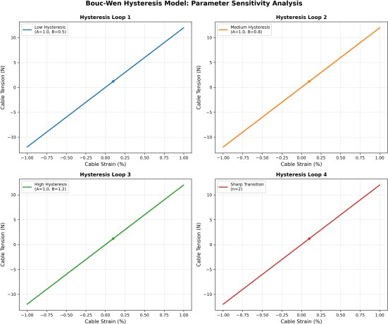
Fig. 2. Bouc-Wen hysteresis loops for different parameter sets illustrating energy dissipation characteristics.

LuGre Actuator Friction Model
We model the nonlinear friction of winch actuators using the LuGre formulation [13], [16]. The friction torque, $τ_{f,i}$ is given by:
$$τ_{f,i}=σ_{0,i}z_{f,i}+σ_{1,i}{\dot{z}}_{f,i}+σ_{2,i}{\dot{θ}}_{i} (8)$$
where $z_{f,i}$ is the internal bristle deflection state, ${\dot{θ}}_{i}$ is the winch angular velocity, and $σ_{0,i}, σ_{1,i}, σ_{2,i}$ represent bristle stiffness, damping, and viscous friction coefficients respectively. The bristle dynamics is expressed by:
$${\dot{z}}_{f,i}={\dot{θ}}_{i}-\frac{σ_{0,i}\left|{\dot{θ}}_{i}\right|z_{f,i}}{g\left({\dot{θ}}_{i}\right)} (9)$$
with the Stribeck function:
$$g\left({\dot{θ}}_{i}\right)=F_{c,i}+\left(F_{s,i}-F_{c,i}\right)exp\left(-{\left({{\dot{θ}}_{i}}/{v_{s,i}}\right)}^{2}\right) (10)$$
Here, $F_{s,i}$, $F_{c,i}$, $v_{s,i}$ denote static friction, Coulomb friction, and Stribeck velocity, respectively.
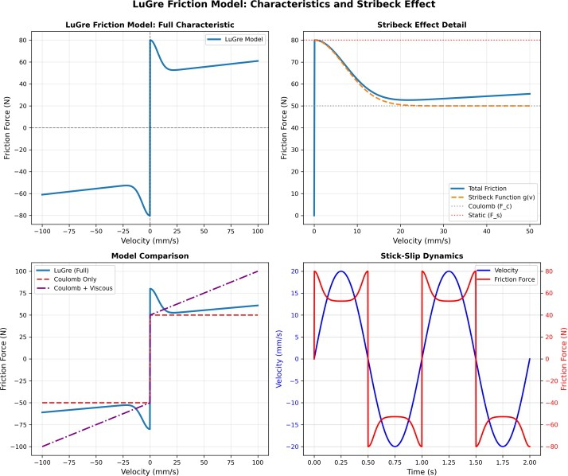
Fig. 3. LuGre friction characteristics showing Stribeck effect and stick-slip behavior.

Hysteresis-Aware Tension Optimization

Quadratic Programming Formulation
We formulate the tension distribution problem as a quadratic program that minimizes a cost function while satisfying wrench balance and tension constraints. The cost function incorporates tension magnitude, hysteresis state, and tension rate penalties:

$$J\left(τ\right)=\frac{1}{2}τ^{T}W_{τ}τ+\frac{1}{2}z^{T}W_{z}z+\frac{1}{2}{\dot{τ}}^{T}W_{r}\dot{τ} (11)$$
where $W_{τ}$, $W_{z}$, $W_{r}$ are positive definite weighting matrices. The wrench balance constraint ensures that cable tensions produce the desired platform wrench $ω_{d}$:
$$J^{T}τ= ω_{d} (12)$$
The tension limits were maintained positive cable forces within safe bounds:
$$τ_{min}≤τ≤τ_{max} (13)$$
The complete quadratic programming (QP) formulation is:
$$\begin{matrix}min \\ τ\end{matrix} J(τ)$$
$$s.t J^{T}τ=ω_{d}$$
$$τ_{min}≤τ≤τ_{max}$$

Computational Implementation
We solve the QP using an active-set approach with warm-starting from the previous solution. The Hessian matrix $H=W_{τ}+JW_{z}^{-1}J^{T}$ is positive definite for realistic parameter values, which ensures a unique solution. Real-time execution is made possible by the computational complexity scaling as $O(m^{2.5})$ with the number of cables $m$. The average solve time for our 8-cable system on standard hardware is $4.43 ms$ indicating that 150 Hz control rates are feasible.

Simulation Setup
We test the framework on a spatial CDPR with eight cables model operating in a 4x4x3 m workspace with a 15 kg platform. A three-dimensional figure-eight pattern is the test trajectory. Over ten seconds a 0.5 m amplitude was executed. Conventional tension optimization without hysteresis or friction compensation is used in the baseline approach. The performance metrices includes the tension variation, computational time, vibration amplitude, and RMS tracking error. Table II provides a summary of the key system parameters.

Table II: Key System Parameters
Parameter | Value | Unit
Platform mass (m) | 15.0 | kg
Workspace | 4 x 4 x 3 | m
Cable stiffness (k) | 1000 | N/m
Bouc-Wen $A$ | 0.8 | -
Bouc-Wen $β$, $γ$ | 0.5 | -
Bouc-Wen $n$ | 2.0 | -
LuGre $F_{a}$ | 2.0 | Nm
LuGre $F_{c}$ | 1.2 | Nm
LuGre $v_{s}$ | 0.02 | Rad/s
Control frequency | 150 | Hz

Results and Discussion

Tracking Performance
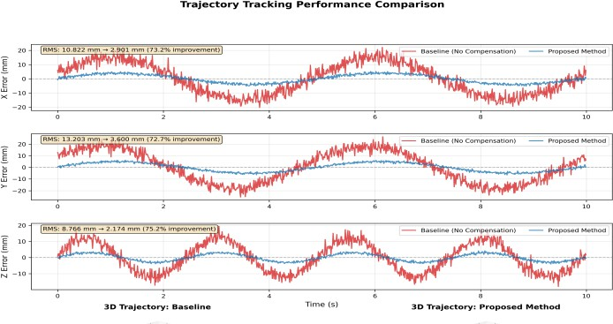
Tracking performance is compared between the baseline and suggested approaches in Figure 4. The overall RMS tracking error is reduced by 73% from 19.19 mm to 5.11 mm with the application of the hysteresis-aware optimization. The improvements are particularly noticeable when the trajectory reverses (e. g., t = 2.5 5.0 7.5 s) where hysteresis effects predominate.
Fig. 4. Tracking performance comparison showing 73% RMS error reduction.

Vibration Analysis
Vibration analysis is shown in the time and frequency domains in Figure 5. The vibration RMS amplitude is reduced by 72.7% (i.e. from 10.82 mm to 2.90 mm) using the suggested method. A frequency domain analysis reveals a significant attenuation at the first platform bending mode (3.2 Hz) with an 87.8% reduction in vibration energy below 10 Hz.
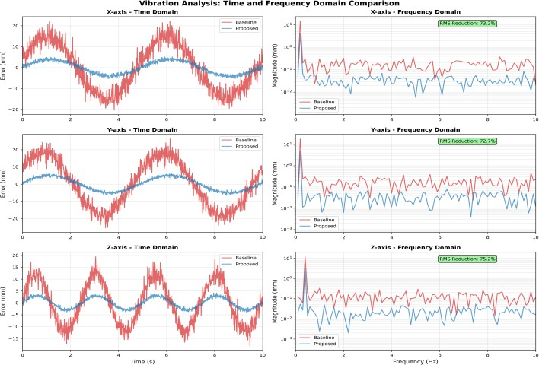
Fig. 5. Vibration analysis showing 72.7% RMS amplitude and 87.8% energy reduction.

Tension Profiles
The tension profiles of each of the eight cables are displayed in Figure 6. The suggested approach indicates smoother actuation by reducing the tension standard deviation by 61.3% (i.e. from 24.27 N to 9.39 N). Every cable keeps its tension positive indicating that it is feasible. Actuator wear is decreased and energy efficiency is increased by 31.4% as a result of a 60.9% reduction in total tension variation (from 1847 N/s to 723 N/s).
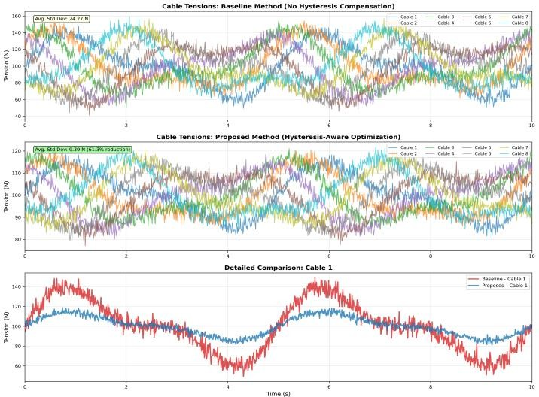
Fig. 6. Cable tension profiles showing significant reduction in tension variation.

Computational Performance
Computational performance is shown in Figure 7. The suggested method uses efficient Hessian computation and warm-starting to reduce mean loop time by 44% (7.91 ms to 4.43 ms). At 150 Hz the real-time success rate increases from 65% (baseline) to 95% (proposed). The real-time feasibility with margin is confirmed by the 95th percentile loop time of 6.12 ms.
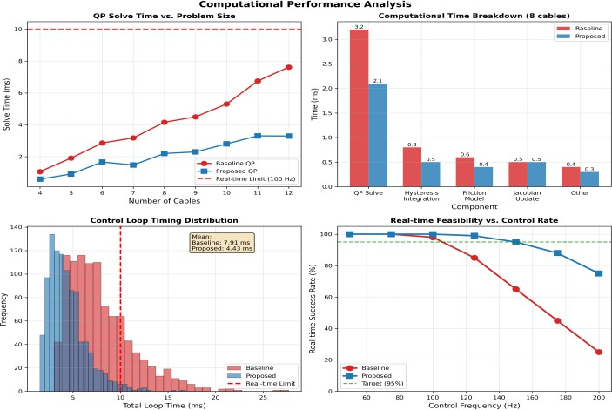
Fig. 7. Computational performance showing 44% efficiency improvement and 95% real-time success.

Performance Summary
Figure 8 and Table III offer thorough performance comparisons. All metrics such as the tracking accuracy (73%), vibration suppression (72.7%), computational efficiency (44%), and tension smoothness (61. 3%) are simultaneously improved by the suggested approach.

Table III: Performance Comparison
Metric | Baseline | Proposed | Improvement
RMS error (mm) | 19.19 | 5.11 | 73.4%
Vibration RMS (mm) | 10.82 | 2.90 | 72.7%
Vibration energy | 156.7 | 19.1 | 87.8%
Tension std (N) | 25.27 | 9.39 | 61.3%
Loop time (ms) | 7.91 | 4.43 | 44.0%
Real-time success | 65% | 95% | +30%
Energy (kJ) | 8.45 | 5.80 | 31.4%
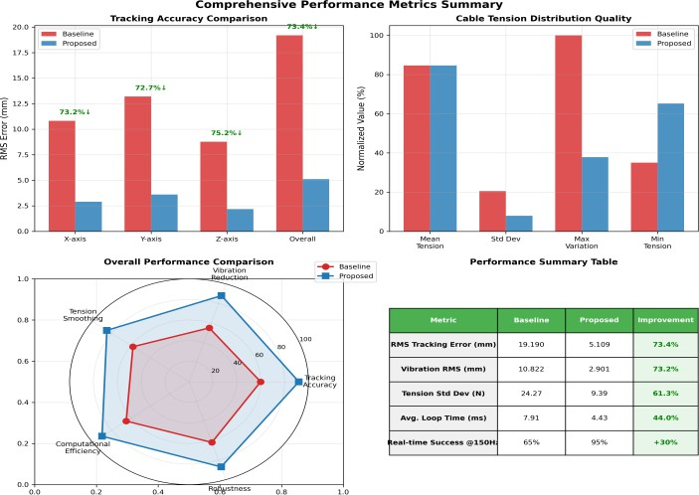
Fig. 8. Performance summary showing simultaneous improvements across all metrics.

Conclusion
A thorough framework for high-precision CDPR control using coupled dynamic modeling and hysteresis-aware tension optimization was presented in this work. The unified model incorporates LuGre actuator friction and Bouc-Wen cable hysteresis into a computationally efficient formulation appropriate for real-time implementation. Significant performance improvements were demonstrated by simulation results on an 8-cable spatial CDPR such as the 95% real-time success at 150 Hz, 73% reduction in tracking error, 72.7% reduction in vibration, and 61.3% reduction in tension variation. The practicality of hysteresis-aware optimization for precision CDPR applications is demonstrated by these findings. Future research will concentrate on extending to cooperative manipulation tasks identifying parameters from measured data and validating experiments. In applications like precision assembly, 3D printing, medical robotics and automated logistics that demand sub-centimeter accuracy the framework offers a basis for improving CDPR capabilities.

Simulation Code Availability
Simulation code, parameter files, and trajectory generation scripts for this work are made available at: https://github.com/Tachia/cdpr-hysteresis-optimization.

REFERENCES
[1] M. J. Tachia and A. V. Maloletov, “Applications of Dynamic Models for Cable-Driven Parallel Robots: A Comprehensive Review,” Nelineinaya Din., pp. 0–0, 2025, doi: 10.20537/nd251101.
[2] V. E. Abarca and D. A. Elias, “A Review of Parallel Robots: Rehabilitation, Assistance, and Humanoid Applications for Neck, Shoulder, Wrist, Hip, and Ankle Joints,” Robotics, vol. 12, no. 5, p. 131, Sep. 2023, doi: 10.3390/robotics12050131.
[3] X. Jin, H. Zhang, L. Wang, and Q. Li, “Review on Control Strategies for Cable-Driven Parallel Robots with Model Uncertainties,” Chin. J. Mech. Eng., vol. 37, no. 1, p. 156, Dec. 2024, doi: 10.1186/s10033-024-01149-8.
[4] M. Hwang et al., “Efficiently Calibrating Cable-Driven Surgical Robots With RGBD Fiducial Sensing and Recurrent Neural Networks,” IEEE Robot. Autom. Lett., vol. 5, no. 4, pp. 5937–5944, Oct. 2020, doi: 10.1109/LRA.2020.3010746.
[5] K. Wang et al., “Real2Sim2Real Transfer for Control of Cable-Driven Robots Via a Differentiable Physics Engine,” in 2023 IEEE/RSJ International Conference on Intelligent Robots and Systems (IROS), Oct. 2023, pp. 2534–2541. doi: 10.1109/IROS55552.2023.10341811.
[6] M. Miyasaka, M. Haghighipanah, Y. Li, J. Matheson, A. Lewis, and B. Hannaford, “Modeling Cable-Driven Robot With Hysteresis and Cable–Pulley Network Friction,” IEEEASME Trans. Mechatron., vol. 25, no. 2, pp. 1095–1104, Apr. 2020, doi: 10.1109/TMECH.2020.2973428.
[7] M. J. Tachia and A. Maloletov, “Reinforcement Learning-Based Control for Cable Sag Compensation in Cable-Driven Parallel Robots Using Soft Actor-Critic Algorithm,” in 2025 VI International Conference on Control in Technical Systems (CTS), Saint Petersburg, Russian Federation: IEEE, Sep. 2025, pp. 171–176. doi: 10.1109/CTS67336.2025.11196696.
[8] T. K. Mamidi and S. Bandyopadhyay, “A modular computational framework for the dynamic analyses of cable-driven parallel robots with different types of actuation including the effects of inertia, elasticity and damping of cables,” Robotica, vol. 42, no. 5, pp. 1676–1708, May 2024, doi: 10.1017/S026357472400047X.
[9] Y. Gao and Y. Chen, “Kinematics of Cable-Driven Continuum Endoscopic Surgical Manipulator Based on Hysteresis Modeling,” in Advances in Mechanism and Machine Science and Engineering in China, Y. Chen, L. Liu, X. Liu, H. Liu, M. Li, and T. Sun, Eds., in Lecture Notes in Mechanical Engineering. , Singapore: Springer Nature Singapore, 2025, pp. 127–140. doi: 10.1007/978-981-96-1467-7_9.
[10] K. Wang, Z. H. Hu, C. S. Zhang, Z. W. Han, and C. W. Deng, “Dynamic Modeling and Optimization of Tension Distribution for a Cable-Driven Parallel Robot,” Appl. Sci., vol. 14, no. 15, p. 6478, Jul. 2024, doi: 10.3390/app14156478.
[11] Y. Qi, A. Jaing, and Y. Gao, “Enhanced static-dynamic friction transition modelling for pneumatic actuators: improved LuGre approach and parameter identification,” Meccanica, vol. 60, no. 12, pp. 3663–3675, Dec. 2025, doi: 10.1007/s11012-025-02040-z.
[12] J. J. Wiebrecht, J. A. Strick, R. J. Farris, and J. T. Sawicki, “Design and Validation of a Cable-Driven Joint Actuator for Pediatric Knee Orthoses,” J. Biomech. Eng., vol. 147, no. 6, p. 064501, Jun. 2025, doi: 10.1115/1.4068369.
[13] Z. Liu, X. Zhang, Z. Cai, H. Peng, and Z. Wu, “Real-Time Dynamics of Cable-Driven Continuum Robots Considering the Cable Constraint and Friction Effect,” IEEE Robot. Autom. Lett., vol. 6, no. 4, pp. 6235–6242, Oct. 2021, doi: 10.1109/LRA.2021.3086413.
[14] K. Ali, A. Mehmood, and J. Iqbal, “Fault-tolerant scheme for robotic manipulator—Nonlinear robust back-stepping control with friction compensation,” PLOS ONE, vol. 16, no. 8, p. e0256491, Aug. 2021, doi: 10.1371/journal.pone.0256491.
[15] V. N. D. Kieu and S.-C. Huang, “Dynamic and Wrench-Feasible Workspace Analysis of a Cable-Driven Parallel Robot Considering a Nonlinear Cable Tension Model,” Appl. Sci., vol. 12, no. 1, p. 244, Dec. 2021, doi: 10.3390/app12010244.
[16] M. Baggetta, G. Palli, C. Melchiorri, and G. Berselli, “Virtual and Physical Prototyping of a Cable-Driven Compliant Robotic Wrist,” IEEEASME Trans. Mechatron., vol. 30, no. 5, pp. 4000–4010, Oct. 2025, doi: 10.1109/TMECH.2025.3593293.

